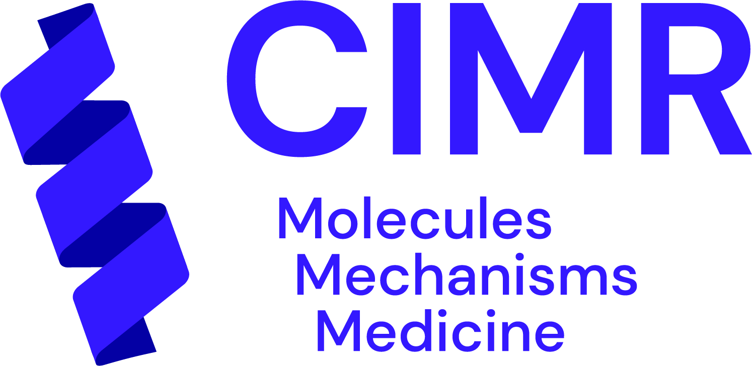

Application form for the Michael House PhD Studentship at
the Cambridge Institute for Medical Research March 2022
*Please note that for funding reasons, we can only offer this studentship to ‘Home’ UK Students.
Please see https://www.postgraduate.study.cam.ac.uk/finance/fees/what-my-fee-status for definitions of Home vs Overseas Student status.

Title

First name(s)

Last name

Date of birth

Nationality*

Basis of Home Student Status*

Correspondence address

Telephone

Email Address

Current University, degree course, expected date of completion and expected grade (if applicable)

Previous University, degree course and result (if applicable)

A-Level subjects (or equivalent) and results

Any academic honours, prizes, outstanding achievements and publications

Describe any research/lab experience that you have had to date, and why it has led you to apply for a PhD (up to 500 words)
Describe (up to 500 words) your scientific interests, why you are applying specifically for the Michael House PhD Studentship and which of the listed projects (shown below in the Appendix) you are interested in (you can select up to 2 projects, in order of preference)

Please attach a full CV with the names and contact details of two academic referees and send all application documents to phdadmin@cimr.cam.ac.uk by
12:00 noon on Wednesday, April 20th 2022.

- General enquiries about the Studentship can be made to phdadmin@cimr.cam.ac.uk
- Specific enquires about the projects on offer to the Studentship can be made to the prospective supervisors (listed in the Appendix below)

Appendix:
Potential projects and Supervisors for the Michael House PhD Studentship at CIMR

#1: A multidisciplinary strategy for understanding mechanisms of rare neurodegenerative diseases
Supervisor: Dr Janet Deane ; jed55@cam.ac.uk
Project summary:
Sphingolipidoses are devastating, early-onset, rare neurodegenerative diseases caused by defects in the ability of cells to process a special class of molecules known as sphingolipids. Our lab combines cell biology, biochemistry and structural biology to investigate the molecular mechanisms that link these lipid imbalances to cell dysfunction and death. We implement newly-developed machine-learning strategies to predict the impact of disease variants and test these hypotheses using cell-based models of disease and in vitro biochemical assays to provide a holistic and molecular understanding of disease.

#2: The molecular pathological mechanisms of hereditary spastic paraplegias (HSP)
Supervisor: Prof. Evan Reid ; ealr4@cam.ac.uk
Project summary:
Hereditary spastic paraplegias (HSP) are a group of single gene disorders that cause axonal degeneration - this causes progressive leg weakness in affected children and adults. The Reid lab studies the molecular pathological mechanisms involved in these conditions. We have two specific PhD projects on offer:
2.1. We have generated human neuronal models of multiple HSP subtypes and have sought unifying mechanisms of pathology. We have found that ganglioside GM2 accumulates in a significant subset of HSPs. We would like to understand i) whether this can be treated with drugs that are known to suppress GM2 accumulation and ii) what the mechanistic basis for this accumulation is. We will approach the latter via functional genomics screens in neurons to identify genes that rescue or enhance the phenotype, with follow-up mechanistic studies of hit genes.
2.2. We have identified defective endosomal tubule fission as a unifying mechanism is several HSPs. One of these is caused by loss of the spartin protein and rescue experiments indicate that spartin must be able to interact with specific ubiquitin ligases of the HECT family to regulate tubulation. This project will explore several mechanistic hypotheses about how dysregulation of this function of spartin leads to defective endosomal tubule fission. A downstream consequence of defective endosomal tubule fission is lysosomal dysfunction and the project will also investigate whether rescue of lysosomal function can improve neuronal morphological phenotypes in neurons lacking spartin.

#3: Rare neurodevelopmental disorders of the mammalian secretory pathway
Supervisors: Dr David Gershlick (dg553@cam.ac.uk) and Prof. Evan Reid (ealr4@cam.ac.uk)
Project summary:
The complex process of membrane trafficking is fundamental to cellular organisation. Proteins are transported from their site of synthesis in the endoplasmic reticulum to the Golgi apparatus where they are sorted to different subcellular localisations, such as the endolysosomal system or directly to the plasma membrane for secretion. There are a variety of diseases caused by mutations in the secretory pathway including several amyloidoses and gammopathies. We are particularly interested in rare novel diseases causes by mutations to the secretory machinery that present as neurodevelopmental disorders. We have developed state of the art cell biology assays to study these diseases using CRISPR technology and have access to rich genetic datasets to discover and characterise these diseases.

